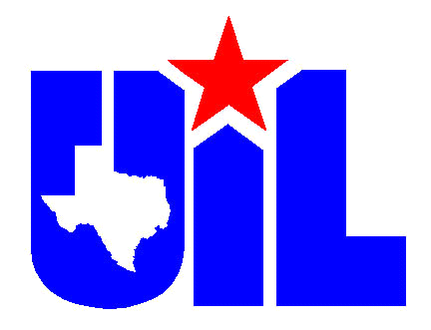

TMEA
_______________

Region 17 Dates for 2016-2017

August
13 Region Meeting – Friendswood JH

September
17 Region Jazz Auditions – Alvin Community College
24 District Choir Auditions – Clear Springs HS

October
6 State Jazz Taping – Alvin Community College
8 JH Region Choir Auditions – Friendswood JH
14 HS Strings Auditions – Westbrook
15 JH Strings Auditions - Westbrook
22 UIL Marching Contest – Clear Creek ISD/ Entry Deadline 09/22/2016
22 HS Choir Region Auditions – Clear Creek HS
22 JH North Zone Region Band Auditions – Victory Lakes
28 JH North Zone Region Band Clinic Concert – Clear Lake Int.
29 HS Orchestra Taping – Clear Lake HS
29 6A UIL Area Marching Contest – Berry Center
29 JH Region Choir Clinic and Concert – Blocker MS
29 JH South Zone Band Region Aud. – Friendswood JH

November
4-5 JH Orchestra Clinic and Concert – Clear Lake HS
8-9 State 6A Marching Contest
10 HS Choir Region Clinic
12 HS Choir Region Concert
11-12 Jazz Region Clinic Concert – Clarion Theatre Brazosport College
11-12 JH Region Band South Zone Clinic/ Concert- Friendswood JH
12-13 HS State Orchestra Judging - Dobie HS
14 Region Orchestra Winds Audition – Alvin HS
15 9th Grade Region Auditions – Alvin HS
18-19 HS Orchestra Region Clinic Concert – Clear Falls HS

December
3 HS Choir Pre-Area Auditions – Shadow Creek HS
5 Region Band Auditions Phase 1 – Alvin HS
6 Region Band Auditions Phase 1 – Alvin HS
8 Region Band Auditions Phase 1 – Alvin HS
10 Region Band Auditions Phase 2 – Alvin HS

January
7 Area Band Auditions - TBA
7 Area Choir Auditions – Ridge Point High School (Fort Bend ISD)
13-14 HS Region Band Clinic/Concert – Manvel HS
28 Orchestra Solo and Ensemble – TBA/ Entry Deadline
01/09/2017

February
4 Band Solo & Ensemble –Clear Lake HS/ Entry Deadline 01/09/2017
8-11 TMEA
18 Choir Solo & Ensemble – Angleton HS/Entry Deadline 01/22/2017

March
2-3 JH Choir CSR – Clear Springs HS/Entry Deadline 01/31/2017

April
4 Varsity HS and MS Orchestras CSR – Clear Brook HS/Entry Deadline
02/30/2017
5-6 HS Choir CSR – United Methodist Church (Dickinson)/Entry Deadline 03/06/2017
8 JH Vocal Solo and Ensemble – Nolan Ryan JH
Entry Deadline 03/22/17
11-12 HS/JH NV and Full Orchestras CSR – Clear Lake HS/Entry
Deadline 03/10/2017
20-22 JH Band CSR – McAdams JH/Entry Deadline 03/22/2017
25-27 HS Band CSR – Clear Lake HS/Entry Deadline 03/27/2017

May
13 Region Meeting – Alvin JH

