Aaron Allison, Band Director
Jeri Collins, Assistant Band Director
Ken Wright, Director of Fine Arts
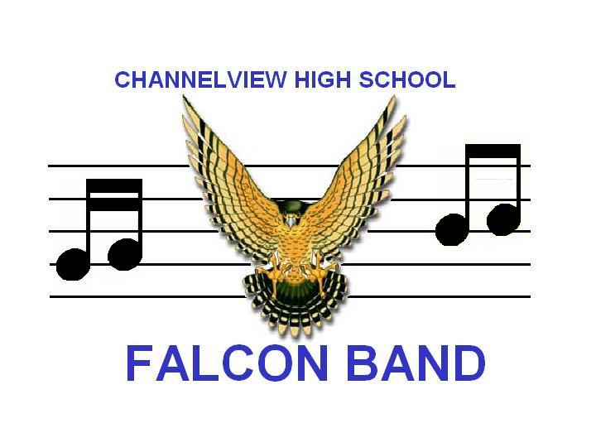
Cindi Ollis, Principal
1100 Sheldon Rd
Channelview, TX 77530
Phone: 281-860-1469
Fax: 281-457-7346

Dear Directors,

Welcome to Channelview High School for the 2015 UIL South Zone Middle School Band Concert and Sight-Reading Contest to be held on March 10th, 11th and 12th. Enclosed you will find:

- Map of Channelview High School
- Map of Channelview High School Contest Layout
- Schedule of performance times

Our school is located on the corner of Sheldon Rd and Crockett. The best way to arrive at the school is to take Beltway 8 to I-10 East. Exit I-10 East onto Sheldon Rd which is the very next exit. Turn left or North onto Sheldon Rd. After Woodforest Blvd (a stop light), you will pass our administration building and stadium. The very next light is Crockett. Turn right onto Crockett. Take the third left turn which will take you into the student parking lot. The student drop off area is by the glass doors between the auditorium and the gym. The equipment trucks will unload at our auditorium loading dock in the same area. After your buses have dropped off students, we ask they park at the far end of the student parking lot until it is time to load again.

Students will enter into the main hallway of the school and you will be met by student representatives from Channelview High School. The band guides will direct you to a waiting area with restrooms available. Because of traffic flows and potential noise, please instruct your students not to leave the group or a guide.

Upon arrival, each director should check in with the contest office located in the band classroom at the end of the band hallway. Remember to have all of your judge’s scores numbered and be sure to write the school name on the front of each. DON’T FORGET YOUR FORM 1.

Student monitors will be assigned to your group upon arrival and lead you through the contest process. Please leave your cases on the bus or truck as there will be no storage available. We also strongly encourage you to have your students dressed upon arrival as we do not provide dressing rooms.

There will be a sufficient number of chairs and stands for each group in the warm-up room, stage and sight-reading rooms. A Peterson tuner and McAdams metronome will be available in the warm-up room.

Equipment available on stage:
- Bass Drum 5. Marimba
- Five Timpani 6. Piano
- Chimes 7. 4x8 Risers with 6" and 12" legs
- Xylophone 8. Acoustical Shells

NOTE: The piano is a concert grand, so please plan your stage setup correctly.

Percussion equipment needed in Sight-reading room:

Level 1- Snare Drum / Bass Drum; Triangle; Bells; Crash Cymbals
(2C-3C Non-Varsity)

Level 2 Snare Drum / Bass Drum; Bells, Triangle, Crash Cymbals; Timpani (2 drums)
2C Varsity)

Level 3 Snare Drum / Bass Drum; Bells; Triangle; Crash Cymbals/
(3C Varsity) Suspended Cymbal; Timpani

NOTE: We will not furnish mallets, sticks, cymbals, snare drums, bells or any accessories.

We will do our best to keep this contest on schedule, so please be prepared to enter warm-up on time and plan to leave the warm-up 5 minutes early. We will have a stage crew to setup your band but we suggest that you have another director available to fine tune your setup. Please instruct your percussion section to setup for the performance. If your stage setup changes from a version you sent, please fax one to me and Ben as soon as possible.

The warm-up room is located in Band Hall C. We request that the door to this room remain closed at all times. After warm-up your monitor will direct you to the auditorium. After your concert performance, you will be lead to Band Hall A for sight-reading. Please note the route provided for all of these changes. Ratings will be given in the contest office. Please make sure to not enter the judge’s room for any reason without Ben’s permission.

Doors to the auditorium will be closed during each performance. The administration of Channelview High School would like all directors to remember that classes are still in session. Please do not allow students to explore CHS or allow them to leave the group. Students must remain quiet in the Fine Arts Hallways due to the close proximity of the three performance areas.

Please keep in contact with your transportation providers. We will keep the contest moving as smooth as possible to ensure an accurate schedule. Upon completion of sight-reading, your group will be led outside to our student drop off area. Please make sure your drivers are aware of the approximate time you will be exiting so that they may have the buses lined up and ready. Please be aware that CHS monitors will not be allowed to watch students without a director. Plan for another director or parent chaperone to monitor your students when you will not be available.

VERY IMPORTANT: If your performance time is between 7-8 am or 2-3 pm, please allow extra time for traffic around our school at these times. If possible, you may consider arriving a little early to have ample time to adjust to the new surroundings.

We wish to do everything in our power to ensure that you and your students have an educational and successful experience here at Channelview High School. If at any time before, during or after you performance you have an issue, please do not hesitate to let me know. We wish you the best of luck during your performances.

Thank you,

Aaron Allison, Head Director Jeri Collins, Assistant Director
281-860-1469 (Office) 281-457-7316
281-705-8470 (Cell) Jeri.collins@channelview.isd.esc4.net
281-457-7346 (Fax)
Aaron.allison@channelview.isd.esc4.net Bryan Mandella, Percussion Coordinador
Bryan.Mandella@channelview.isd.esc4.net

