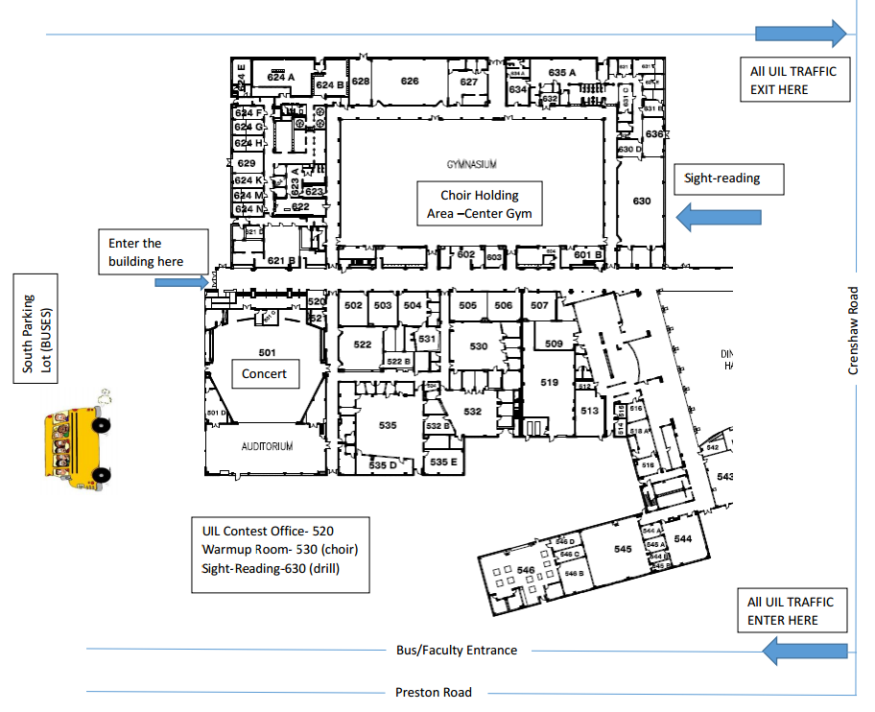

Contest Office – 520

Warm Up- 530 Choir Room

Sightreading- 522 Black Box