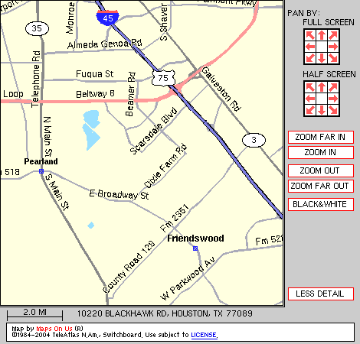
Map to Dobie

Blackhawk Rd.
—
Same exit as
Beamer off the Beltway coming
from IH
-
45. Go through the light
at Beamer and take a Left at the
next street. The school is a half
mile down on the right. Enter the
driveway immediately past the
elementary school.

Elementary
School

Dobie High School

Auditorium

Marquee

Park
Here

Enter

Here

Students will be at the entrance
to show you where to uncase
and warm
-
up.

Beltway 8

Blackhawk Rd.

