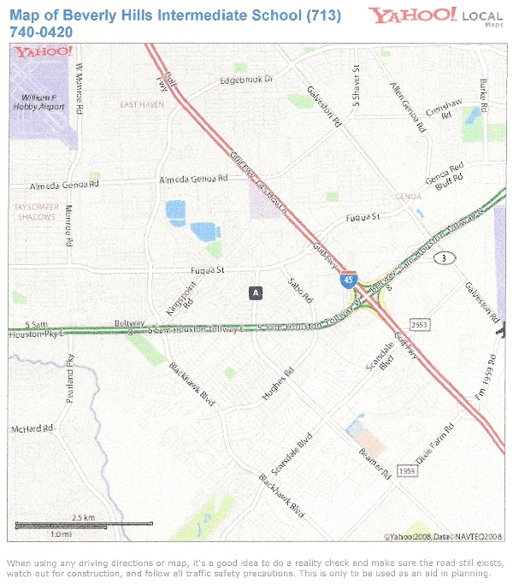

BEVERLY HILLS INTERMEDIATE SCHOOL
11111 BEAMER ROAD
HOUSTON, TX 77089

