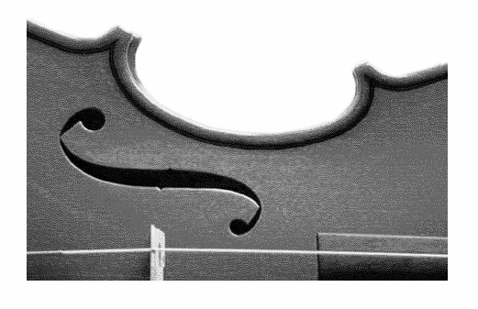
Sam Rayburn High School
ORCHESTRA
2121 CHERRYBROOK LN. · PASADENA, TX 77502 · 713-740-0330

UNIVERSITY INTERSCHOLASTIC LEAGUE
REGION XIX UIL MUSIC
HIGH SCHOOL ORCHESTRA CONCERT/SIGHTREADING CONTEST
SAM RAYBURN HIGH SCHOOL
FEBRURARY 29 – MARCH 2, 2012
Dear Director,

Sam Rayburn High School welcomes you to our campus for the 2012 UIL High School Orchestra Concert and Sightreading Contest to be held Wednesday February 29th through Friday March 2nd. Enclosed in this packet of information you will find:

- Map to Sam Rayburn High School
- Map of Sam Rayburn High School with Contest Layout
- List of performance times

Buses will enter the Fine Arts Parking lot on the Burke side of the school and drop off students at the door labeled Fine Arts Hall, and after unloading the buses may park in the back of the lot. All students and equipment drop-off and pick up should be at the doors labeled Fine Arts Hall. If your time is between 7:00-8:00 or 2:00-3:00 plan extra time because traffic in front of the school can get pretty bad during these times.

A student monitor will meet your group to lead you through the contest process. Each director should check in at the contest office in the medium ensemble room, located at the first door on the left as you enter the Fine Arts Hall. Be prepared to leave your judges’ scores and Form #1 with the Contest Chairman in the Contest Office. Remember, you must have all of your measures numbered, and be sure to write your school’s name on the front of every score.

Your student monitor will lead your organization to a case storage area. Purses and valuables will not be secured; Sam Rayburn High School offers no liability for any personal losses. Please only bring what you need to successfully perform. Bass players will need to provide their own stools. Do not forget to bring rock stops for cellos and basses.

There will be a sufficient number of chairs and stands for each group in each of the following areas: (1) Warm-up, (2) Stage, and (3) Sight-reading. A McAdams metronome/tuner will be available in the warm-up and in the Sight-reading room.

Equipment furnished on the stage:
1. Bass Drum
2. Four (4) Timpani
3. Chimes
4. Xylophone
5. Gong
6. Piano (concert baby grand, plan your stage set-up with this in mind)
7. Acoustical Shell

Equipment needed for Sight-reading:
Full Orchestra Level III (3C): Tambourine, Bass Drum
Full Orchestra Level V (4A): Timpani (G & D), Snare Drum, Bass Drum, Triangle
Full Orchestra Level VI (5A): Timpani (G & D), Bells, Snare Drum, Bass Drum, Triangle

NOTE: We will not furnish mallets, sticks, cymbals, snare drums, orchestra bells, or any other accessory.

We plan to keep this contest on schedule, so be prepared to enter warm-up on time and leave the warm-up room 5 minutes early. We will have a stage crew to help you, but will need some help from 2 or 3 people from your school for “fine tuning” your set-up. Your set-up will only be as accurate as the diagram you send. If your set-up changes from the original you sent, please fax a new one to Stephen Payne at 713-740-4157.

Doors to the auditorium will remain closed during each performance, and will only be opened between performances. Please remember you are the guests at this school. Classes, as well as the contest, are in progress, so please monitor your group and be quiet and respectful at all times. Students must remain quiet in the hall before you enter warm-up. Please do not allow students to enter the warm-up room or performance areas until you move to these locations. If you must bring groups early or stay late, please remind your groups of appropriate concert behavior and monitor them very closely. Keep your group(s) together and supervised. Additionally, if you must bring groups early or stay late, please notify me, Stephen Payne, at least 24 hours before the contest begins. With your notification we will be better prepared to accommodate your ensemble.

In conclusion, I hope that this contest will be organized to run smoothly, and I want to wish each of you the best of luck during the competition. If I can be of any further assistance, please do not hesitate to call. School phone: 713-740-0330 x02210 or Cell phone: 713-294-5390.
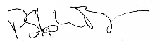

Sincerely,
P. Stephen Payne
Director of Orchestras
Sam Rayburn High School
713-740-0330 x02210
ppayne@pasadenaisd.org

