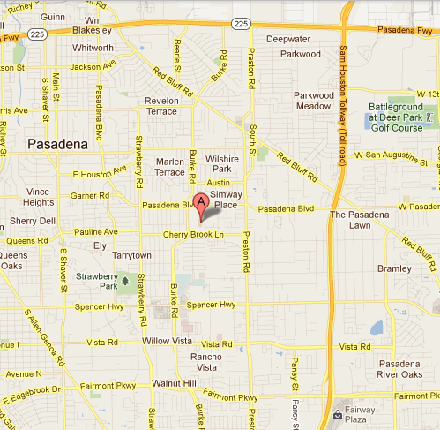
Sam Rayburn HS
Directions

Directions from the North
South on Sam Houston Tollway
Exit “Red Bluff Rd/Pasadena Blvd”
Turn right onto Pasadena Blvd
Turn left onto Burke Rd
Sam Rayburn HS is on the left

Directions from the South
North on Sam Houston Tollway
Turn left onto Spencer Hwy
Turn right onto Burke Rd
After passing Cherrybrook Ln, Sam Rayburn HS will be on right

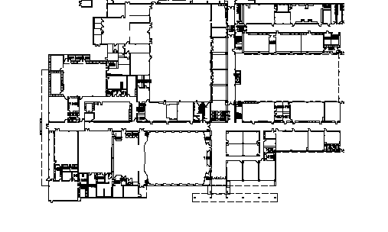
Sam Rayburn HS
Campus Map

Contest Locations:
Fine Arts Parking Lot (Burke Rd.)
1. Contest Office
2. Unpacking Area
3. Warm-up Room
4. Concert Stage
5. Sightreading Room

Cherrybrook Parking Lot

