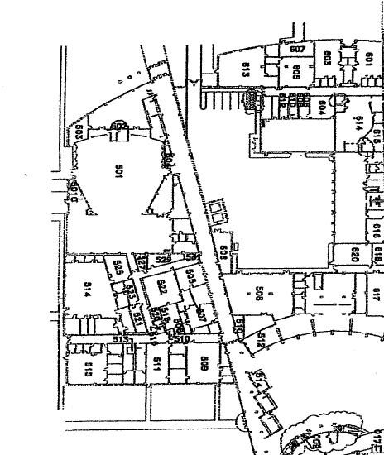
Back Parking Lot –This is
where you will unload

-

.

Side
parking lot.

Band Tower.

This is where the
Buses will park
.

Warm-up

S
ightreading

Stage
Area

.

Contest

O
f
fice
Contest Entrance

