How to enter UIL Concert & Sightreading Using Charms
- Log into Charms, then click on the Assessment Icon. If your login does not match the UIL database a red icon will appear to sync the two accounts.
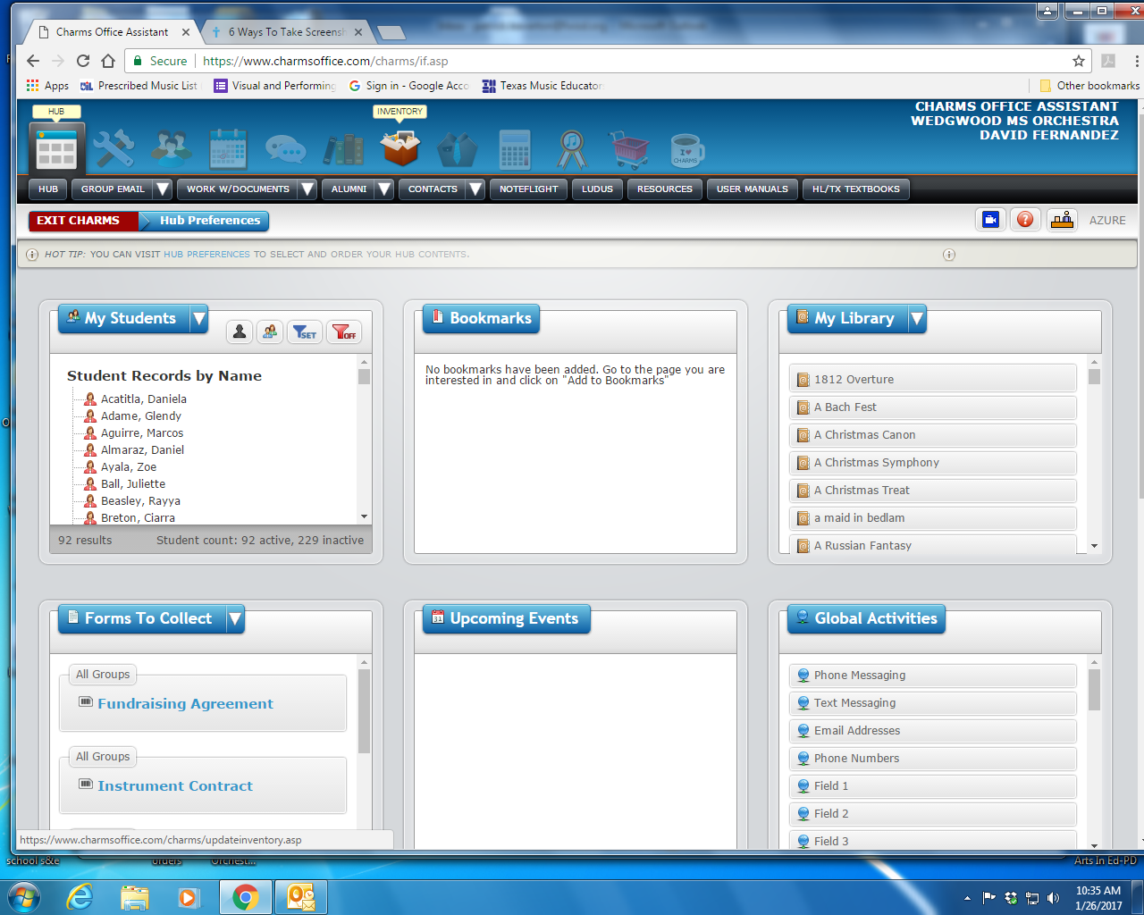
- Click on UIL entries, Select Form 4 – C&SR
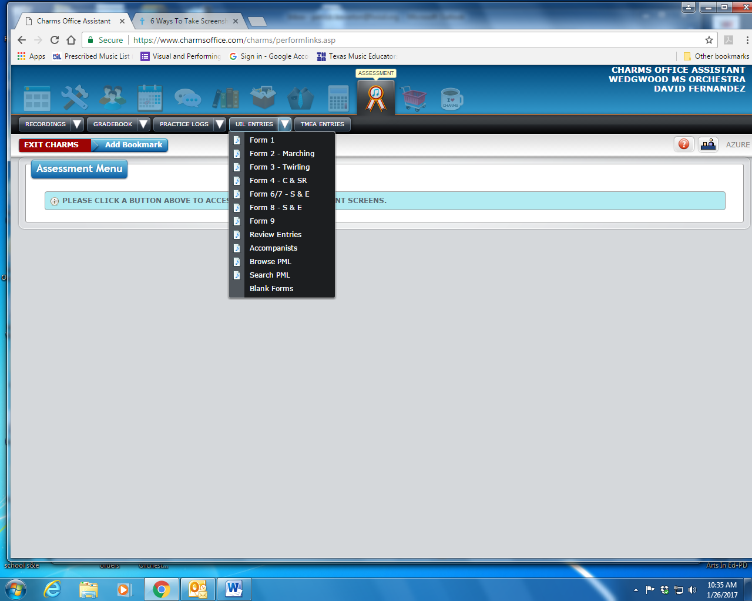
- Fill Out ALL the Information. It is best to enter these in performance order. Hit submit entry at the bottom of the page (you might have to scroll down). It will give you the option of printing a form 4 (judge comment sheet). I encourage you to do this to confirm your information.
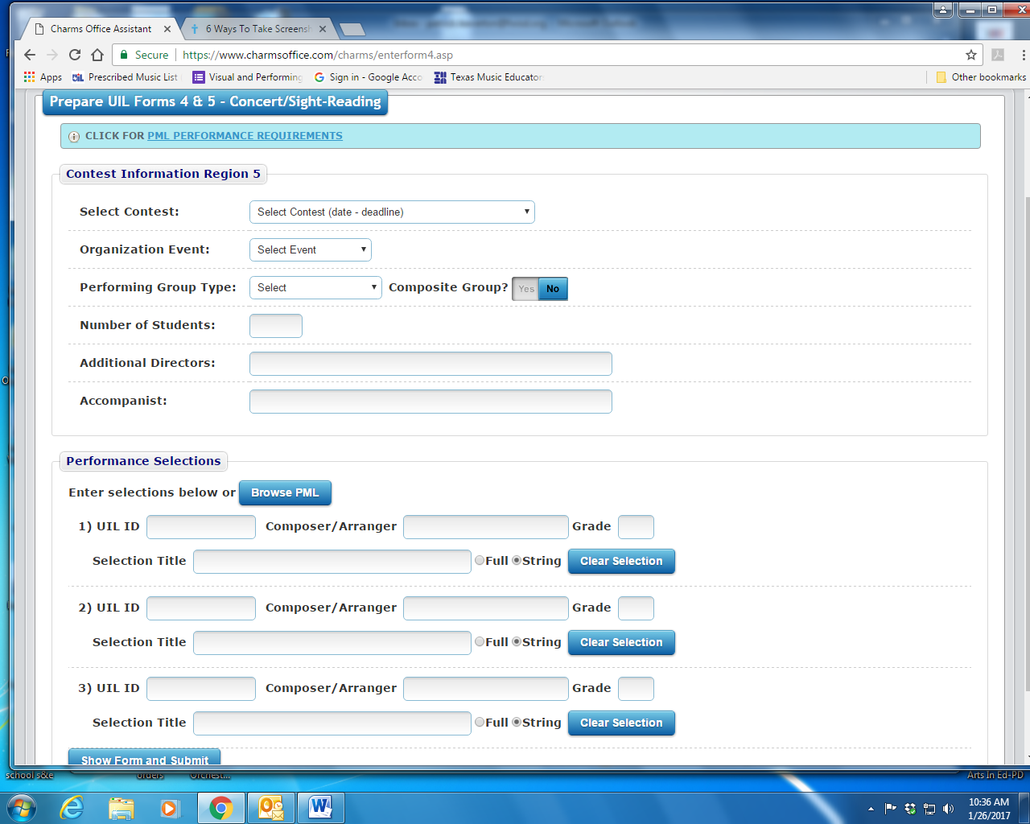
- Go up to the drop down menu and select Review Entries
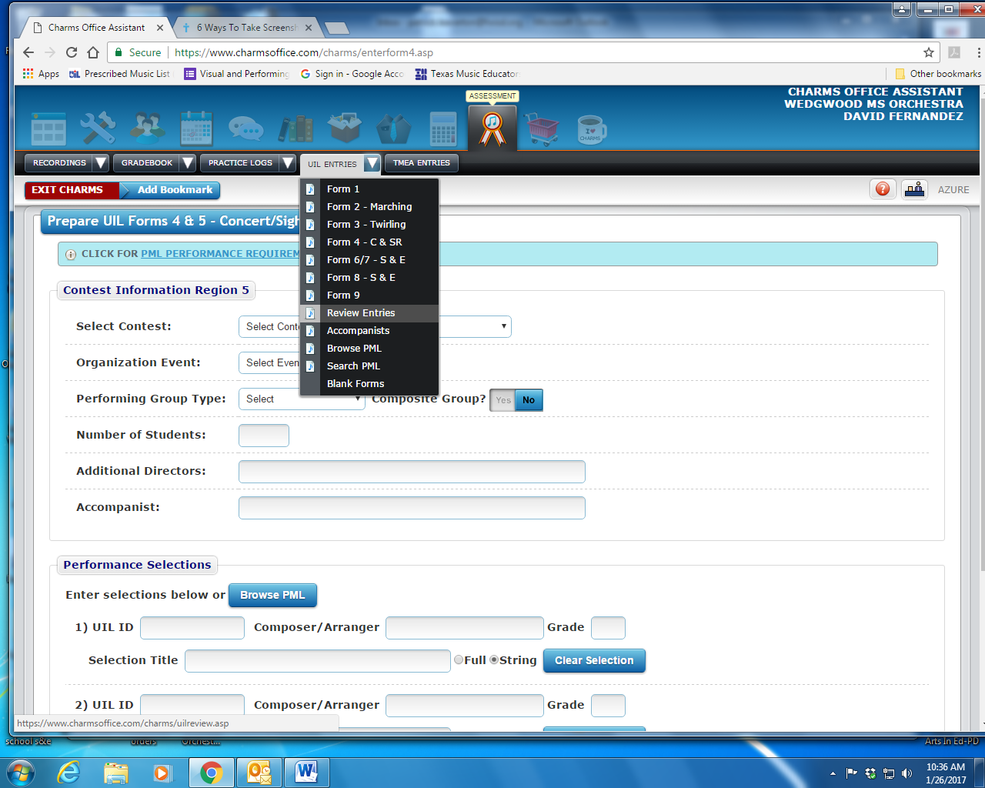

- Select the contest that you entered your group, and then check your entry to make sure everything is correct. Next, click on Print Invoice. This needs to be emailed or delivered to the Fine Arts Office so your fee can be paid. They will mail/Deliver one check to Region 5 UIL.
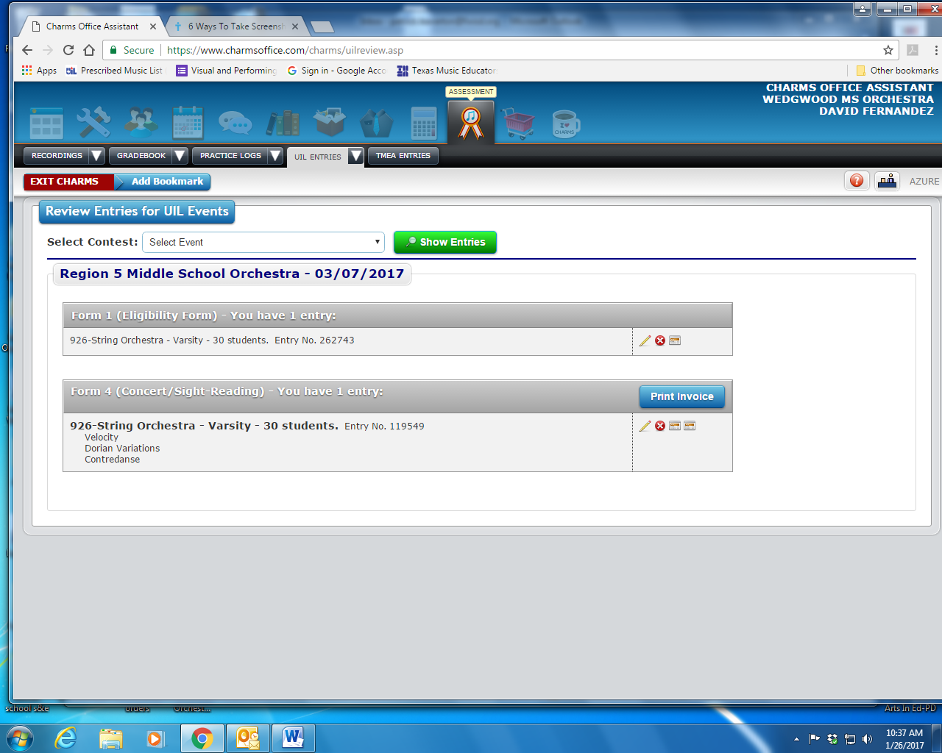
- Go back to the drop down menu and select Form 1.
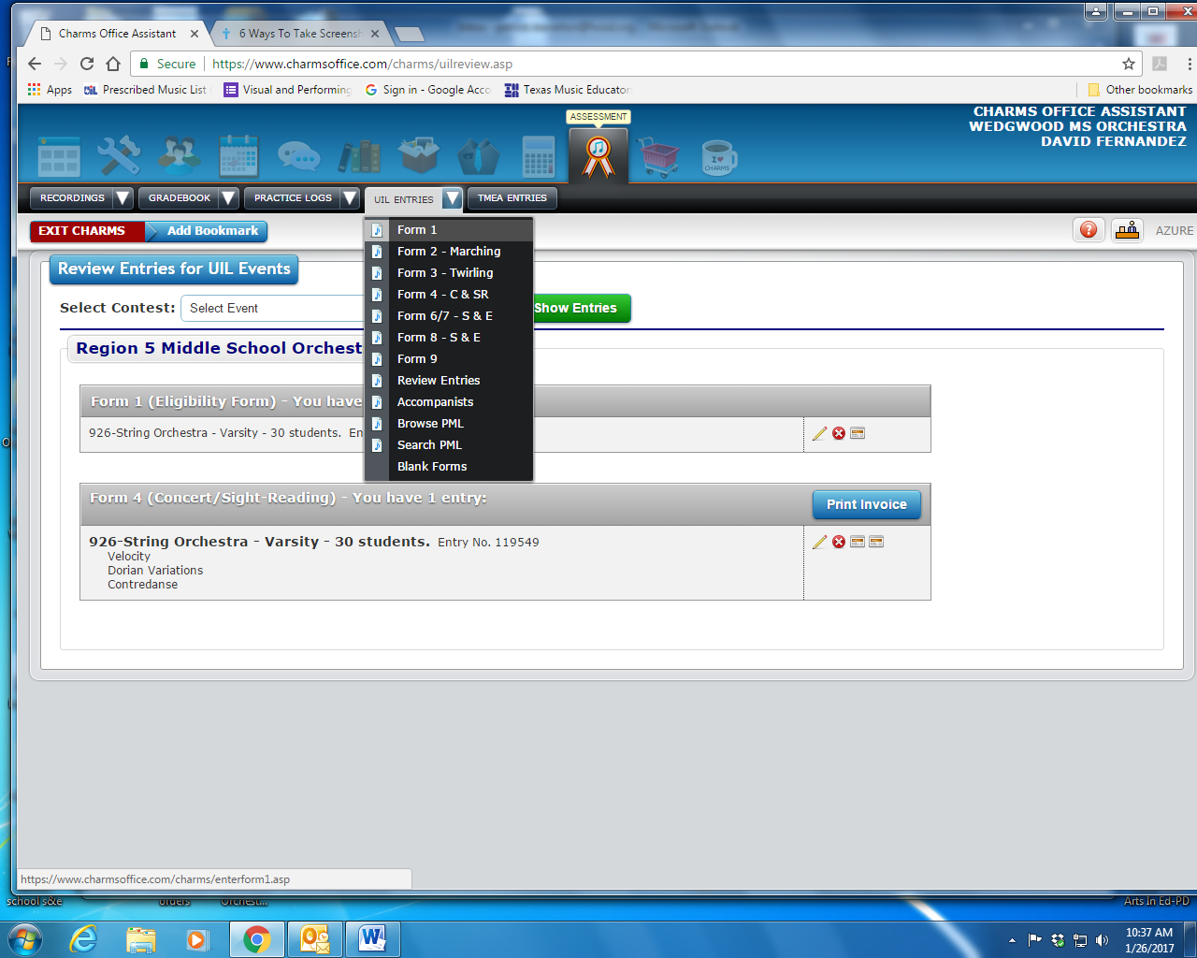
- Fill Out the information in the top, select which kids are eligible and in that group, print out and have your principal sign the form. You can fill this out again if eligibility changes before contest.
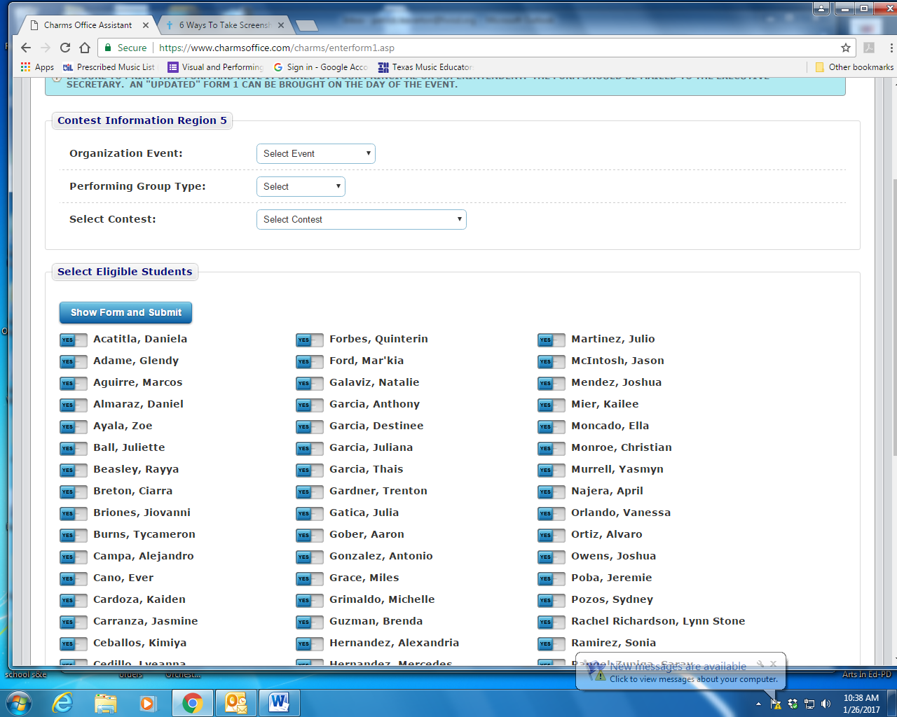

- Repeat these steps for each of the groups you are entering. If you are at multiple campuses you must have a separate login for each campus.

